Brand Evaluation System From Big Data On The Amazon E-Commerce Platform
Ngo-Ho Anh-Khoi¹ , Nguyen Anh-Duy¹ , Vo Khuong-Duy¹ and Nguyen-Hong Tin^{1*}
¹ Nam Can Tho University, Can Tho, Vietnam
nhakhoi@nctu.edu.vn, naduy@nctu.edu.vn, vkduy@nctu.edu.vn, tin219819@student.nctu.edu.vn
Abstract: Amazon generates large-scale user reviews that provide valuable evidence for brand evaluation, yet transforming such unstructured data into actionable insights remains challenging. This study proposes an integrated Brand Evaluation System for Amazon-based big data that combines automated review collection, scalable data organization, sentiment analysis, and Large Language Models (LLMs) for contextual interpretation. Beyond conventional review mining based on keyword frequency or aggregate ratings, the proposed system identifies positive and negative sentiment tendencies across products, extracts brand-level strengths and weaknesses, and produces structured brand-oriented analytical outputs. These outputs provide interpretable evidence for brand reputation assessment and support more informed decision-making in e-commerce brand management.
Keywords: Brand evaluation, data collection, large language model, sentiment analysis.
- Introduction
In the digital era, understanding consumer perceptions of brands has become a critical factor for business competitiveness and long-term sustainability. On modern e-commerce platforms, customer opinions are continuously expressed through reviews, ratings, and product-related interactions, creating a large and dynamic source of market intelligence. Among these platforms, Amazon represents a particularly valuable environment for brand analysis because of its global reach, product diversity, and extensive volume of user-generated reviews. These reviews capture authentic consumer experiences and provide insights that can support strategic decisions in product development, marketing, customer service, and brand positioning.
Despite the availability of such large-scale data, extracting meaningful brand-level insights from online reviews remains a major challenge. Traditional brand evaluation methods, including surveys, manual content analysis, and periodic audits, are often time-consuming, costly, and limited in scalability. In parallel, many conventional automated review analysis methods still depend heavily on keyword counting, simple polarity classification, or average rating aggregation. Although these methods can provide a basic summary of consumer sentiment, they often fail to capture contextual nuances, implicit opinions, and more complex patterns in customer feedback. As a result, they may provide an incomplete representation of brand perception in fast-changing digital marketplaces.
To address these limitations, this study proposes a Brand Evaluation System From Big Data On The Amazon E-Commerce Platform, designed to transform large-scale Amazon review data into structured and actionable brand insights. The system automatically collects a substantial volume of reviews from Amazon, stores them in a suitable database architecture, and applies natural language processing techniques for large-scale sentiment-oriented analysis. To enhance interpretability beyond conventional score-based methods, the framework further incorporates Large Language Models (LLMs) to support contextual understanding of review content and more comprehensive synthesis of consumer opinions. Through this combination, the system aims to move beyond simple review summarization toward a more meaningful evaluation of brand perception, including the identification of positive and negative tendencies, recurring strengths and weaknesses, and interpretable signals relevant to brand reputation.
The primary objective of this research is not only to automate review collection and analysis, but also to establish an integrated analytical framework for brand evaluation on Amazon-based big data. In particular, this study makes three main contributions. First, it develops an automated pipeline for collecting and organizing large-scale Amazon review data for brand-oriented analysis. Second, it combines sentiment-oriented natural language processing with LLM-assisted contextual interpretation to improve the quality and depth of review understanding. Third, it implements a demonstration system that enables users to visually track, explore, and interpret brand-related analytical results. Through these contributions, the study seeks to expand the practical application of data analytics and AI-assisted language understanding in the field of e-commerce brand evaluation.
- Literature Review
Brand equity has evolved from a conventional marketing indicator into a core strategic intangible asset in modern business management. Aaker (1991) defined brand equity as a multidimensional construct composed of assets and liabilities such as brand associations, perceived quality, and brand loyalty that add value to customer experience. Building on this foundation, Keller (1993) introduced the Customer-Based Brand Equity (CBBE) perspective, emphasizing that brand strength is shaped by what consumers have learned, felt, seen, and heard about the brand over time. These foundational perspectives, further reflected in frameworks such as Keller’s Brand Resonance Pyramid and BrandZ’s hierarchical models, underscore that consumer perception is central to brand value and therefore central to any practical brand evaluation system.
Historically, brand management activities such as positioning, identity development, and governance were commonly supported by periodic brand audits and traditional market research methods. These evaluations typically relied on manual qualitative and quantitative techniques, including Likert-scale surveys, interviews, and SPSS-based statistical analysis. Although such approaches provide structured evidence, they are often constrained by limited sample sizes, delayed reporting cycles, and high implementation costs. In rapidly changing digital marketplaces, these limitations create a significant data-latency problem, where insights may become outdated before they can support managerial decisions. As a result, more dynamic, scalable, and data-driven brand evaluation approaches have become increasingly necessary, especially in environments where customer opinions are continuously generated through online interactions (Rizqy & Nabilla, 2025; Mustikasari et al., 2025).
The growth of e-commerce platforms has fundamentally changed how brand perception can be observed and analyzed. Instead of relying solely on surveys or periodic audits, organizations can now examine large-scale user-generated reviews as naturally occurring evidence of consumer attitudes in near real time. Among e-commerce environments, Amazon is particularly valuable because of its global reach, product diversity, and extensive volume of user-generated review data. In this context, sentiment analysis and review mining have become important tools for transforming unstructured textual feedback into measurable analytical signals relevant to brand evaluation.
However, conventional sentiment analysis remains limited when applied to complex review data. Many legacy approaches focus on broad positive–negative polarity classification or depend on surface-level indicators such as keyword frequency and aggregate star ratings. While computationally efficient, these methods often fail to capture implicit sentiment, mixed opinions, contextual nuances, and feature-specific evaluations. More recent developments in Fine-Grained Sentiment Analysis and Aspect-Based Sentiment Analysis (ABSA) provide a more suitable direction for brand evaluation because they enable the identification of specific product or service attributes such as quality, durability, delivery speed, or customer service that shape customer satisfaction or dissatisfaction (Şilcenco et al., 2025). This shift from coarse polarity detection to more diagnostic and interpretable analysis is particularly important for brand evaluation, where the objective is not only to determine whether consumers are satisfied, but also to understand why a brand is perceived positively or negatively. In addition, AI-mediated digital interactions, including recommendations and adaptive interfaces, increasingly form part of the broader brand experience, reinforcing the need for analytical systems that can interpret customer feedback within richer contextual settings (Ahmed & Khan, 2025).
The emergence of Large Language Models (LLMs) has significantly expanded the analytical potential of online review mining. Compared with conventional sentiment pipelines, LLM-based approaches can better capture semantic relationships across words, sentences, and broader discourse contexts, enabling more comprehensive interpretation of nuanced consumer opinions. This is especially relevant in e-commerce reviews, where users often express contradictory, implicit, or context-dependent judgments. Recent studies suggest that LLMs can support deeper understanding of brand-related signals when integrated with structured analytical methods. For example, combining LLMs with Qualitative Comparative Analysis (QCA) has been used to identify causal configurations of service and product attributes that contribute to brand trust (Davoodi & Mezei, 2024). Likewise, sarcasm-aware sentiment analysis framed as a Textual Entailment problem using models such as NLI-DeBERTa has improved the reliability of sentiment interpretation by distinguishing literal wording from underlying negative intent (Sinha et al., 2024). Recent scholarship has also emphasized that LLM-assisted systems should remain attentive to fairness, calibration, and reliability, particularly in decision-support contexts where biased or unstable outputs may distort brand-related interpretations (Au Duong, 2024; Niimi, 2025; Ngo & Ngo, 2026). Collectively, these studies indicate that LLMs are not merely generic text generators, but increasingly important components of interpretable and trustworthy analytical systems for large-scale brand evaluation.
At the same time, practical deployment requires attention to model adaptation and system design. In the Vietnamese research context, PhoBERT has demonstrated the importance of language-specific preprocessing strategies such as Byte Pair Encoding (BPE) and RDRsegmenter for improving sentiment classification quality (Nguyen & Nguyen, 2023). Similarly, domain-specific LLMs such as eCeLLM have shown strong zero-shot and out-of-domain (OOD) generalization, suggesting that adapted models can be beneficial when evaluating unfamiliar product categories (Peng et al., 2024). At the system level, recent work has also highlighted the value of structured orchestration and benchmark-aware evaluation in AI-assisted pipelines, including automated benchmark generation mechanisms such as VQABG for domain-relevant ground-truth construction (Ngo Ho et al., 2024). These developments support the broader transition from isolated text-classification tasks toward integrated analytical systems.
Despite these advances, the current literature remains fragmented. Prior work has largely focused on four separate streams: (1) conceptual brand equity models, (2) traditional survey-based brand measurement, (3) sentiment classification and aspect-based review mining, and (4) emerging LLM-assisted contextual interpretation. However, relatively limited attention has been given to end-to-end, deployable systems that unify automated large-scale Amazon review collection, scalable sentiment-oriented analytics, LLM-assisted contextual interpretation, and structured brand-oriented outputs for managerial use. Therefore, this study addresses that gap by proposing an integrated Brand Evaluation System From Big Data On The Amazon E-Commerce Platform, designed to transform large-scale Amazon review data into more interpretable, actionable, and brand-relevant evaluation outcomes.

- Proposed System
This study proposes a practical framework for a brand evaluation system on the Amazon e-commerce platform:
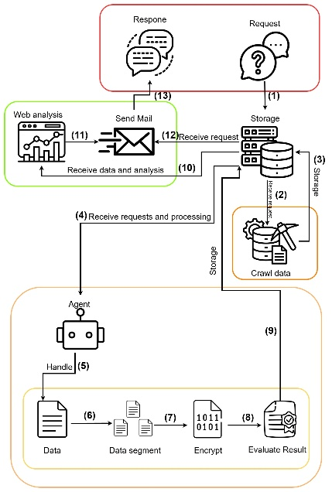
Figure 3.1 Overview Diagram Proposed by the Study

The system’s implementation process begins when the user submits a request including basic personal information and, importantly, the name of the brand to be evaluated along with an email address to receive the results after the evaluation process is complete. Upon receipt, this information is stored in the database and flagged with status = 0. At this point, the data scraping API activates; it fetches requests with status = 0 and begins the scraping process. During data collection, the status is updated to status = 1. After the data collection is completed, the results are stored in the database, and the status is recorded as status = 2.
Next comes the analysis phase by the Evaluating-Agent, which starts processing the collected data. During processing, the status is set to status = 3. Broadly speaking, the Agent retrieves data from the database, splits it into chunks, performs sentiment analysis and ratio calculations, evaluates the data, and returns it to the Agent. The evaluated data is then stored back into the database with the status updated to 4. The SeMail-API monitors for entries with status = 4 and sends an email to the user containing a link to the analysis webpage. This webpage presents the information processed by the Agent in a visual format with evaluation indicators specific to Amazon.
Selenium – Data Collection Framework: This study proposes collecting product information from Amazon, including product names, prices, number of reviews, comments, etc. (Satheeshkumar & Meeranandhini, 2025). Big data processing: applies natural language processing algorithms such as preprocessing, sentiment analysis, keyword extraction, ratio calculation, and result aggregation, then sends the final outcomes. Information visualization: a website visualizes the processed information and applies metrics characteristic of Amazon (Satheeshkumar & Meeranandhini, 2025; Wu et al., 2025).
The data collection phase serves as the foundation for all brand perception analyses. With the explosive growth of social media and e-commerce platforms, user-generated data is increasing at an unprecedented rate (Hashmi & Yayilgan, 2025). To exploit this vast and diverse data source, this study uses Selenium, a powerful browser automation tool. Selenium is chosen for its ability to interact with dynamic websites, simulate real user behavior (e.g., scrolling, clicking, filling forms), and collect data from JavaScript-generated content capabilities that traditional static HTML parsers find difficult to achieve
However, automated data collection from these platforms faces many technical challenges. Anti-bot mechanisms are a significant barrier. Many websites implement measures such as CAPTCHA, abnormal behavior detection, and IP blocking to prevent automated data extraction. To overcome these obstacles, sophisticated strategies are required, such as proxy rotation, using headless browsers, and inserting random delays between requests to mimic human behavior (Satheeshkumar & Meeranandhini, 2025) . Rotating User-Agent headers in HTTP requests is also an important method to avoid being flagged as a bot.
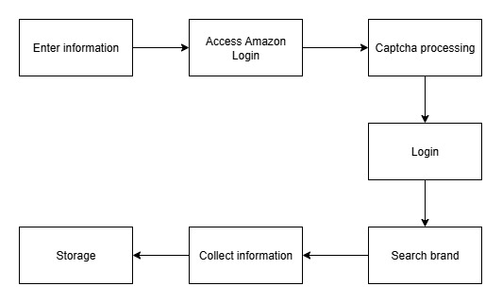
Figure 3.2 Architecture of the Data Collection System on Amazon
Based on theoretical foundations and practical challenges, this study proposes a data collection pipeline starting with brand requests retrieved from the database. Using Selenium and WebDriver, the system logs into Amazon to access product reviews (Satheeshkumar & Meeranandhini, 2025) . Login may involve solving image- or audio-based CAPTCHAs specific to Amazon. After successful login, the system searches for brand-related products and collects product details and user reviews, skipping irrelevant items. For Vietnamese language processing, text normalization especially diacritic removal is essential, given the prevalence of mixed or non-standard Vietnamese in Amazon reviews. Although PhoBERT is monolingual, it remains effective for sentiment analysis after normalization (Nguyen & Nguyen, 2023) . Fine-tuning on specific review data further improves its adaptability to noisy, bilingual inputs, making it a practical choice under resource constraints (Tabassum, 2025) . To enhance sentiment analysis, LangChain and GPT-based LLMs are used for keyword and entity extraction via chunking and chain-of-thought prompting (Wang, 2025; Au Duong, 2024) . This hybrid setup combines PhoBERT’s Vietnamese expertise with GPT’s contextual reasoning, resulting in a flexible, efficient evaluation system tailored for analyzing Vietnamese brand perception on Amazon (Hashmi & Yayilgan, 2025).
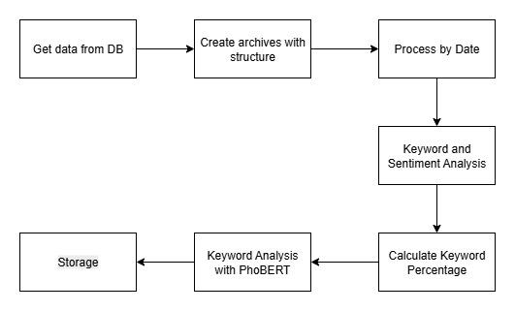
Figure 3.3 Overview diagram of LLM operation
Text splitting is essential in LLM-based systems due to context window limitations, requiring long documents to be divided into smaller segments for efficient processing. Although not always explicitly labeled, LangChain supports this functionality to prepare data for models like PhoBERT, which also has token limits (Nguyen & Nguyen, 2023). Document loading in LangChain allows integration with external sources like web scraping APIs (e.g., Oxylabs), automating the entire pipeline from data collection to LLM processing. Its sequential "chain processing" links components step by step, creating organized workflows and transforming raw data into valuable insights through prompt chaining (e.g., chain = prompt | OpenAI()) (Ngo Ho et al., 2024). LangChain also enables output parsing converting free-text responses from LLMs into structured data for downstream use. Though not always termed explicitly, functions like response.choices.text.strip() support this by cleaning outputs for tasks like sentiment classification and entity extraction (Hartmann & Netzer, 2023) . Its core strength lies in seamless LLM integration, abstracting API complexities and offering a unified interface (Ngo Ho et al., 2025). Integration with models like GPT-4o mini allows contextual understanding, flexible reasoning, and application in areas such as sentiment analysis (Au Duong, 2024) . With end-to-end capabilities from text splitting to analysis LangChain serves as a powerful framework for building scalable AI solutions, especially in enterprise contexts where AI adoption is growing (Rizqy & Nabilla, 2025).
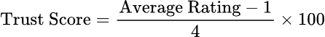
Average Rating: The average rating score (scale 1-5)
Trust Score: The trust score (scale 0-100%)
Brand Growth Formula: Estimates the brand’s growth potential based on the current trust score.
Trust Score: Current trust score
Brand Growth: Predicted brand growth
Sentiment Index Formula: Calculates the average sentiment index from two different AI models to assess the reliability of the sentiment analysis.
GPT Positive: Positive rating ratio from GPT
PhoBERT Positive: Positive rating ratio from PhoBERT
Brand Health Score Formula: Overall evaluation of brand health based on trust score and sentiment, with a weighted priority given to sentiment.
Trust Score: Trust score (weight 40%)
GPT Positive: Positive rating ratio from GPT
PhoBERT Positive: Positive rating ratio from PhoBERT
Average Sentiment: Weight 60%
Sentiment Diversity Formula: Measures the degree of diversity in customer perceptions of the brand.
GPT Positive: Positive rating ratio from GPT
PhoBERT Positive: Positive rating ratio from PhoBERT
PhoBERT Neutral: Neutral rating ratio from PhoBERT
Sentiment Balance Index Formula: Measures the balance between positive and negative ratings; a positive value indicates a leaning toward positivity.
GPT Positive: Positive rating ratio from GPT
GPT Negative: Negative rating ratio from GPT
Customer Loyalty Index Formula: Evaluates customer loyalty based on positive sentiment and trust score.
GPT Positive: Positive rating ratio from GPT
Trust Score: Brand trust score
Keyword Richness Formula: Measures the richness of the vocabulary customers use to describe the brand.
Count Positive: Number of positive keywords
Count Negative: Number of negative keywords
Word Impact Ratio Formula: Measures the impact level of positive keywords relative to the total keywords used.
Positive Word Frequency: Frequency of positive keywords
Total Word Frequency: Total frequency of all keywords
Sentiment Balance Index (SBI) Formula: This formula measures the balance between positive and negative sentiment.
GPT Positive: Positive review rate from GPT (%)
GPT Negative: Negative review rate from GPT (%)
SBI: Sentiment Balance Index (%)
Sentiment Stability Formula: Measures the stability of sentiment over time by comparing the differences between two AI models.
GPT Positive_i: Positive review rate from GPT in year i
PhoBERT Positive_i: Positive review rate from PhoBERT in year i
n: Number of years analyzed
- Experiment
To ensure objectivity and consistency, experiments were conducted in a controlled environment with clearly defined scenarios. The system ran on hardware including an AMD Ryzen 7 4800H CPU, NVIDIA GeForce GTX 1650 GPU, 16GB RAM, and a 512GB SSD, ensuring stable processing. Software-wise, it used Ubuntu 22.04, with Python 3.10.4 and PHP as core languages. Backend services were built using FastAPI 0.115.12 and Laravel 9, and AI functionalities integrated libraries like Selenium 4.29.0 and LangChain 0.3.20, meeting automation and NLP requirements.
The test scenario focused on a multinational tech brand known for computer peripherals, using top LLMs such as GPT-4o mini, Gemini 1.5 Flash, and Claude 3 Sonnet. After collecting and processing over 3,000 reviews from 20 Logitech products on Amazon, the system generated performance metrics, including execution time and model-specific outputs:
Model | GPT-4o mini | Gemini 1.5 Flash | Claude 3 Sonnet
Positive Rate | 81.54% | 79.23% | 77.65%
Negative Rate | 18.46% | 20.77% | 22.35%
Neutral PhoBERT | 23.05% | 25.18% | 26.92%
Sentiment Index | 78.44% | 75.12% | 73.89%
Customer Loyalty Idx | 80.77% | 77.94% | 76.02%
Sentiment Balance Idx | 63.08% | 58.32% | 55.78%
Sentiment Diversity | 59.97% | 62.13% | 61.45%
Keyword Richness | 18017 | 17134 | 16988
Execution time | 9480s ~ 157m | 12060s ~ 201m | 11220s ~ 187m
Table 4.1 Performance Comparison Table of LLM Models
This data table presents the brand evaluation metric sets applied using different LLM models. Each model exhibits variations in stability, indicator sets, and processing time, resulting in distinct advantages and disadvantages. Therefore, the choice of model depends on specific evaluation needs. Among the three models presented, the most optimal appears to be the GPT-4o mini, which achieved the shortest processing time of 157 minutes (equivalent to 2 hours and 37 minutes), despite the relatively large dataset which still has room for optimization, to be discussed in Chapter 6.
The following chart compares the Amazon brand evaluation scores using the proposed set of indicators in this study:
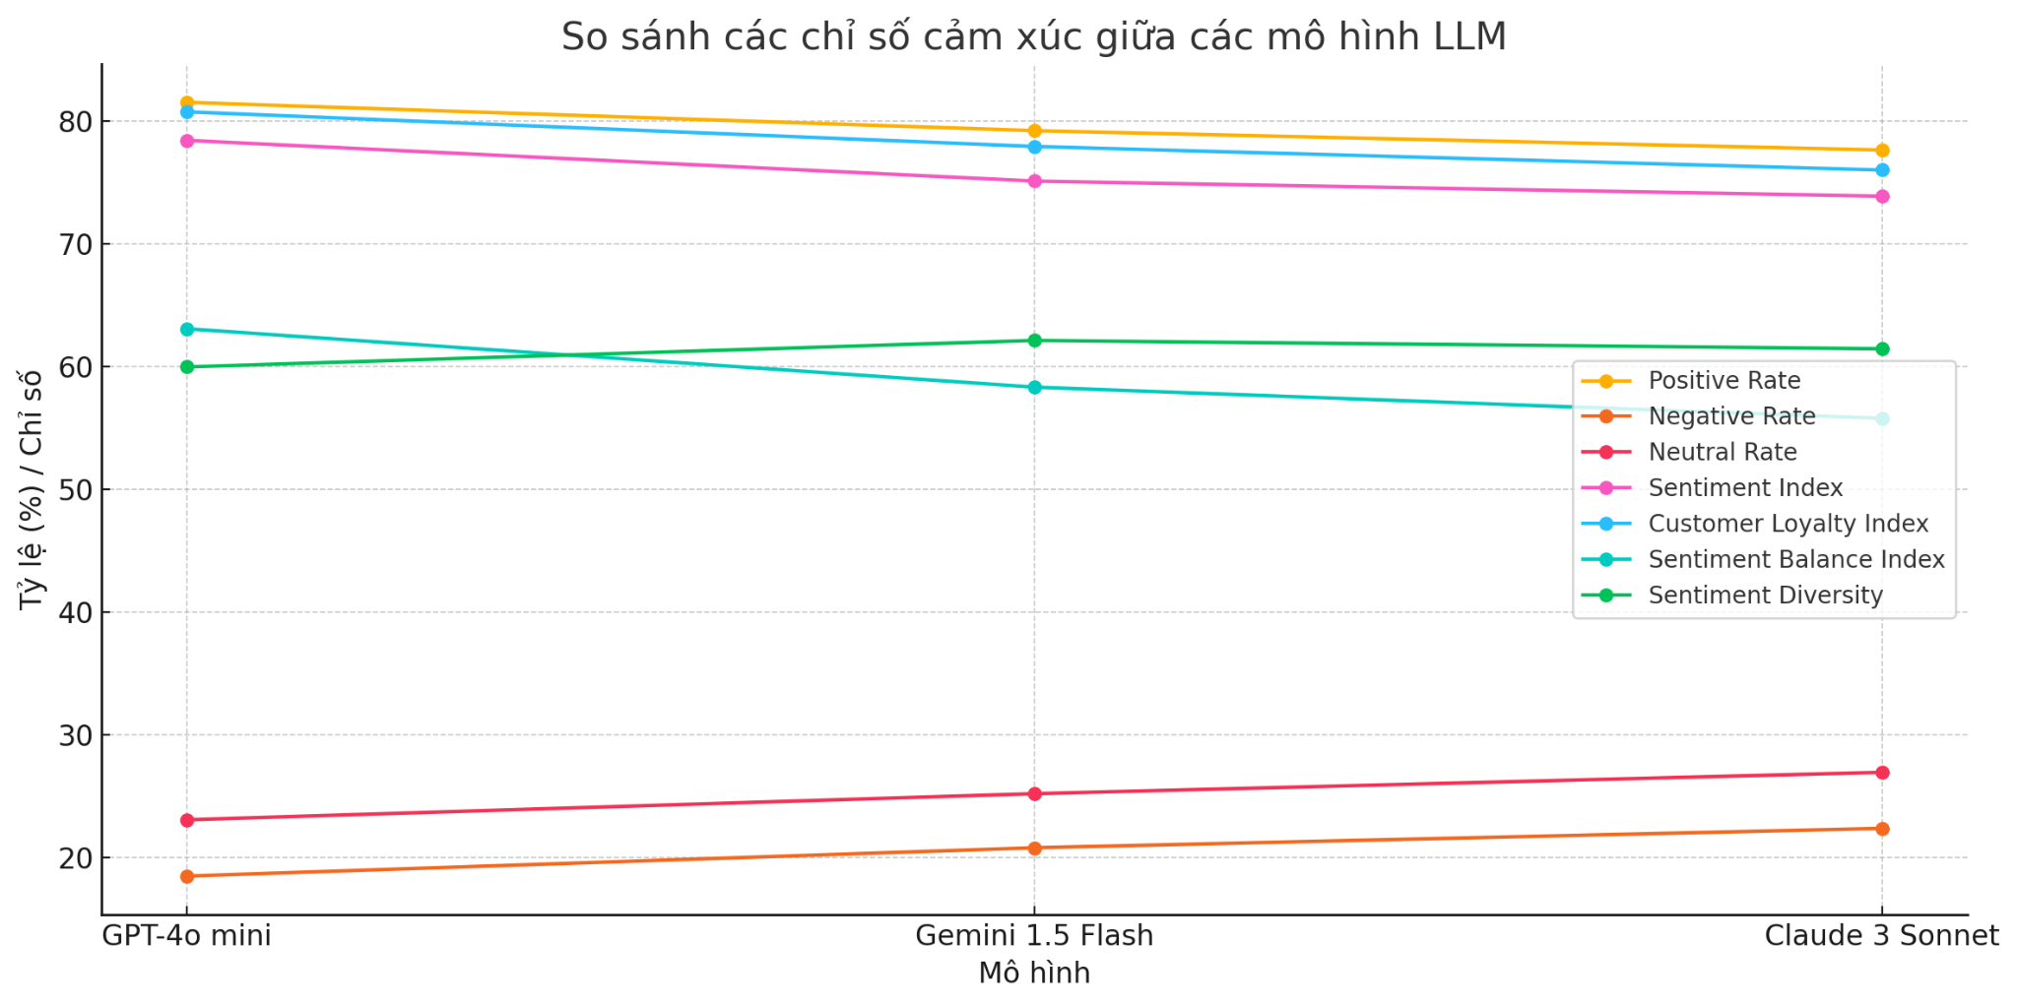
Figure 4.1 Comparison Chart of LLM Model Metrics

It can be seen that the GPT-4o mini model clearly outperforms Gemini 1.5 Flash and Claude 3 Sonnet in certain metrics, but more notably, its execution time stands out in the chart below:
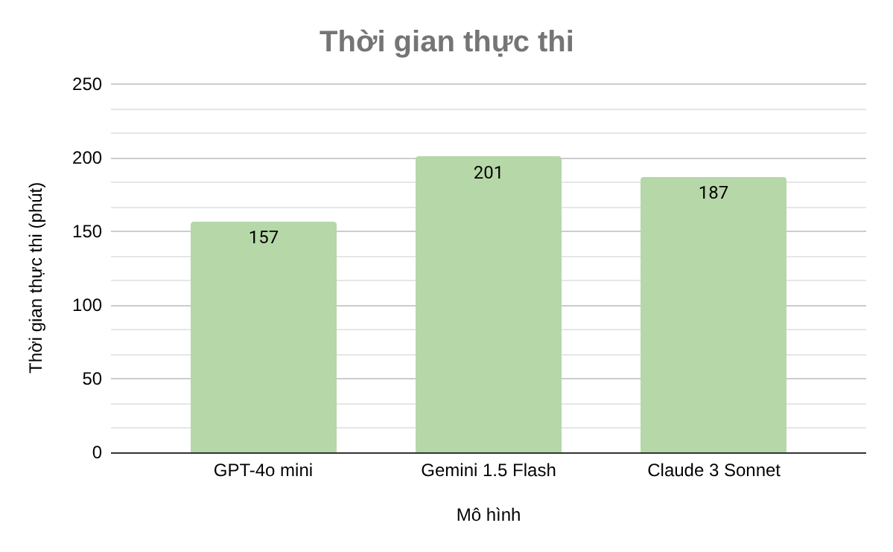
Figure 4.2 Execution Time Bar Chart

Although the execution time difference between GPT-4o mini and Claude 3 Sonnet is not significant at this stage, it is important to note that this is based on only 20 products (with over 3,000 reviews). This gap is likely to widen as the dataset increases to 50 or 100 products.
- Conclusion
After completing the research, design, and testing phases, the project successfully developed a comprehensive brand evaluation system tailored for the Amazon e-commerce platform. It addresses the growing challenge of analyzing massive online data by integrating advanced technologies such as automated large-scale data collection, AI Agent-powered sentiment analysis, and context-aware evaluation using LLMs. The system has demonstrated the ability to extract, analyze, and synthesize brand insights effectively, outperforming traditional methods in understanding nuanced customer feedback. The architecture combining PhoBERT and LLMs proved to be efficient, transparent, and scalable, laying a strong foundation for a multidimensional brand assessment tool.

To further enhance the system, future development should focus on improving AI capabilities by fine-tuning models on more diverse datasets and integrating visual analysis through Image AI. Expanding data sources beyond Amazon (e.g., social media, other marketplaces) and handling richer media formats (like video reviews) will provide a more holistic brand view. Personalization features and trend forecasting, powered by predictive analytics, can support proactive decision-making. Finally, transitioning the system into a SaaS platform with user management, subscription plans, and a scalable cloud infrastructure will enable widespread commercial use and long-term sustainability.

References
- Nguyen, D. V., & Nguyen, N. L. T. (2023). Is Word Segmentation Necessary for Vietnamese Sentiment Classification? arXiv. Retrieved from https://arxiv.org/pdf/2301.00418
- Hartmann, J., & Netzer, O. (2023). Natural Language Processing in Marketing [Collected papers]. Columbia University. Retrieved from https://www.columbia.edu/~on2110/Papers/HartmannNetzer2023.pdf
- Mustikasari, A., Hurriyati, R., Dirgantari, P. D., Sultan, M. A., & Sugiana, N. S. S. (2025). The Role of Artificial Intelligence in Brand Experience: Shaping Consumer Behavior and Driving Repurchase Decisions. The Scientific World Journal, 4. Retrieved from https://thesai.org/Downloads/Volume16No4/Paper_32-The_Role_of_Artificial_Intelligence_in_Brand_Experience.pdf
- Ngo Ho, AK., Vo, KD., Ngo Ho, AK. (2025). Evaluation of Large Language Models for the Vietnamese Language in Generative Vietnamese Economy Chatbots (GVEC) Services. In: Yeom, S. (eds) 6th International Conference on Electronics and Signal Processing (ICESP 2024). Signals and Communication Technology. Springer, Cham. https://link.springer.com/chapter/10.1007/978-3-031-94973-9_19
- Ngo, K. H. A., & Ngo, K. H. A. (2026). NEM: A numerical exact match subtype aware metric family for explainable numerical accuracy in specialized chatbots. In Proceedings of the 39th International Conference on Industrial, Engineering & Other Applications of Applied Intelligent Systems (IEA/AIE 2026)
- Ngo Ho, A. K., Vo, K. D., & Ngo Ho, A. K. (2024). VQABG: Vietnamese question/answers benchmark generator for field specific chatbot ground truth dataset using EMINI (Exact Match wIth Numeric Information) indicator. CTU Journal of Innovation and Sustainable Development, 16 (Special issue: ISDS), 80 90. https://ctujs.ctu.edu.vn/index.php/ctujs/article/view/1160
- Ngo Ho, A. K., Vo, K. D., Nguyen, A. D., & Ngo Ho, A. K. (2024). Evaluating university brand reputation in the digital age: Proposed AI driven metrics for social media rankings. In Proceedings of the 12th International Conference on Emerging Challenges: Sustainable Strategies in the Data Driven Economy
- Davoodi, L., & Mezei, J. (2024). A Large Language Model and Qualitative Comparative Analysis-Based Study of Trust in E-Commerce. Applied Sciences. Retrieved from https://doi.org/10.3390/app142110069
- Satheeshkumar, S., & Meeranandhini, T. V. (2025). Real-Time Competitor Strategy Tracking and Analysis for E-commerce Using AI. International Journal of Science and Advanced Technology (IJSAT). Retrieved from https://www.ijsat.org/papers/2025/2/5400.pdf
- Sinha, S., Vijeta, T., Kubde, P., Gajbhiye, A., Radke, M. A., & Jones, C. B. (2024). Sarcasm Detection in Product Reviews using Textual Entailment approach. ACM Digital Library. Retrieved from https://doi.org/10.1145/3639233.3639252
- Peng, B., Ling, X., Chen, Z., Sun, H., & Ning, X. (2024). eCeLLM: Generalizing Large Language Models for E-commerce from Large-scale, High-quality Instruction Data. Retrieved from https://arxiv.org/pdf/2402.08831
- Hashmi, E., & Yayilgan, S. Y. (2025). A robust hybrid approach with product context-aware learning and explainable AI for sentiment analysis in Amazon user reviews. Retrieved from https://doi.org/10.1007/s10660-024-09896-5
- Wu, Q., Xia, C., & Tian, S. (2024). AI-Driven Sentiment Analytics: Unlocking Business Value in the E-Commerce Landscape. Retrieved from https://arxiv.org/pdf/2504.08738
- Tabassum, S. (2024). LLM Based Sentiment Classification From Bangladesh E-Commerce Reviews. Retrieved from https://arxiv.org/pdf/2510.01276
- Au Duong, W. Y. (2024). Leveraging ChatGPT as a Tool for Sentiment Analysis and the Influence of Gender and Location Information. Retrieved from https://arno.uvt.nl/show.cgi?fid=171964
- Şilcenco, O., Machado, M. R., Ugulino, W. C., & Braun, D. (2024). A Retail-Corpus for Aspect-Based Sentiment Analysis with Large Language Models. Responsible-NLP. Retrieved from https://arxiv.org/pdf/2508.17994
- Rizqy, R. S., & Nabilla, N. S. (2025). AI and Big Data in E-Commerce: Amazon's Digital Innovation in Its Operational Processes. ASBNIC. Retrieved from https://doi.org/10.64458/asbnic.v2.66
- Niimi, J. (2025). Reference Points in LLM Sentiment Analysis: The Role of Structured Context. Retrieved from https://arxiv.org/pdf/2508.11454
- Wang, Y. (2025). Sentiment Analysis of Product Reviews Using Fine-Tuned LLaMa-3 Model: Evaluation with Comprehensive Benchmark Metrics. Retrieved from https://www.itm-conferences.org/articles/itmconf/pdf/2025/01/itmconf_dai2024_04021.pdf

